**Connect to Hiring Partners through your Udacity Professional Profile**

[[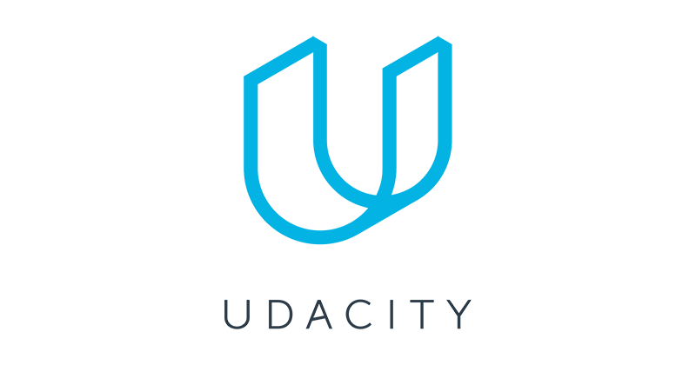](https://classroom.udacity.com/nanodegrees/nd027/parts/1be1ed3e-c0c5-4b03-be23-7f4393a11fca/modules/20001b0c-9bbd-49c3-b0f2-5d1578fa6e22/lessons/42bc312a-38dd-4953-8695-3735a251b1db/concepts/e30b19ac-662a-463f-9ff5-3d784b2e72db)](https://classroom.udacity.com/nanodegrees/nd027/parts/1be1ed3e-c0c5-4b03-be23-7f4393a11fca/modules/20001b0c-9bbd-49c3-b0f2-5d1578fa6e22/lessons/42bc312a-38dd-4953-8695-3735a251b1db/concepts/e30b19ac-662a-463f-9ff5-3d784b2e72db)

In addition to the Career Lessons and Projects you'll find in your Nanodegree program, you have a Udacity Professional Profile, which can be accessed through your Career Portal. Once in the Career Portal, simply click on the "Edit Profile" next to your name, and you will be taken to your Udacity Professional Profile:

[[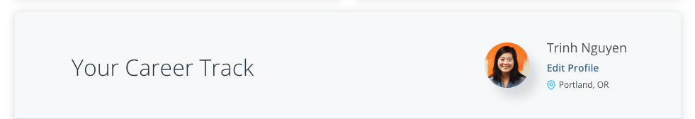](https://classroom.udacity.com/nanodegrees/nd027/parts/1be1ed3e-c0c5-4b03-be23-7f4393a11fca/modules/20001b0c-9bbd-49c3-b0f2-5d1578fa6e22/lessons/42bc312a-38dd-4953-8695-3735a251b1db/concepts/e30b19ac-662a-463f-9ff5-3d784b2e72db)](https://classroom.udacity.com/nanodegrees/nd027/parts/1be1ed3e-c0c5-4b03-be23-7f4393a11fca/modules/20001b0c-9bbd-49c3-b0f2-5d1578fa6e22/lessons/42bc312a-38dd-4953-8695-3735a251b1db/concepts/e30b19ac-662a-463f-9ff5-3d784b2e72db)

Your Udacity Professional Profile features important, professional information about yourself. When you make your profile public, it becomes accessible to our Hiring Partners.

Your profile will also connect you with recruiters and hiring managers who come to Udacity to hire skilled Nanodegree graduates.

As you complete projects in your Nanodegree program, they will be automatically added to your Udacity Professional Profile to ensure you're able to show employers the skills you've gained through the program. In order to differentiate yourself from other candidates, make sure to go in and customize those project cards. In addition to these projects, be sure to:

* Keep your profile updated with your basic info and job preferences, such as location
* Ensure you upload your latest resume
* Return regularly to your Profile to update your projects and ensure you're showcasing your best work

If you are looking for a job, make sure to keep your Udacity Professional Profile updated and visible to recruiters!